**DAILY ONLINE ACTIVITIES SUMMARY**

|  |  |  |  |  |  |  |  |  |
| --- | --- | --- | --- | --- | --- | --- | --- | --- |
| **Date:** | **01/08/2020** | | | | | **Name:** | **NAIPUNYA VINOD NAIK** | |
| **Sem & Sec** | **IV SEM & A SECTION** | | | | | **USN:** | **4AL18CS050** | |
| **Online Test Summary** | | | | | | | | |
| **Subject** | | **NO INTERNALS CONDUCTED** | | | | | | |
| **Max. Marks** | | **30** | | **Score** | | | **-------------** | |
| **Certification Course Summary** | | | | | | | | |
| **Course** | **1)** PAGE OBJECT MODEL PATTERN FOR SELENIUM WEBDRIVER & JAVA | | | | | | | |
| **Certificate Provider** | | | **1)UDEMY** | | **Duration** | | | **1)3.5 HRS** |
| **Coding Challenges** | | | | | | | | |
| **Problem Statement: NO PROBLEM STATEMENT GIVEN TODAY** | | | | | | | | |
| **Status:------------------** | | | | | | | | |
| **Uploaded the report in Github** | | | | | **YES** | | | |
| **If yes Repository name** | | | | | <https://github.com/naipunya-naik/daily-progress-report> | | | |
| **Uploaded the report in slack** | | | | | **YES** | | | |

Online Test Details: (Attach the snapshot and briefly write the report for the same).

NO INTERNALS CONDUCTED TODAY

Certification Course Details: (Attach the snapshot and briefly write the report for the same).

CERTIFICATION COURSE NAME:- PAGE OBJECT MODEL PATTERN FOR SELENIUM WEBDRIVER & JAVA

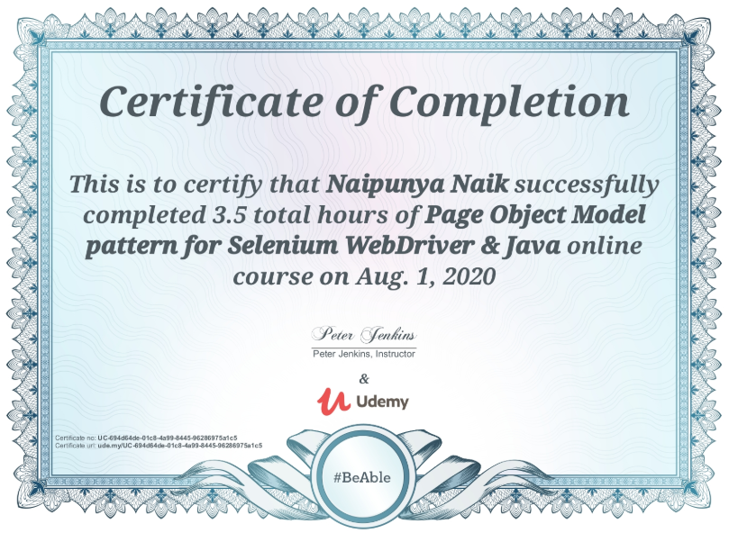

Coding Challenges Details: (Attach the snapshot and briefly write the report for the same).

NO PROBLEM STATEMENT GIVEN TODAY